◎PROFILE 1
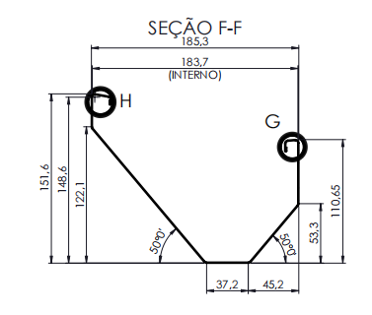
PROFILE 2
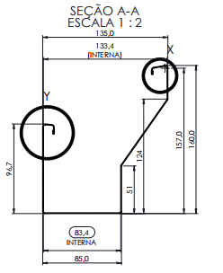

◎Material
Applicable Material:Galvanized Sheet Coil & Cold Rolled Steel
Materail Thickness:0.8mm；Feeding Width:400mm;
Material Yield Strength:235-345Mpa；
Effective Width Tolerance:±1mm；
The Wave Height Tolerance:±1mm；
The Length Of Tolerance:±1mm(6m)；
◎Work Flow
Hydraulic Uncoiler→Feeding Guide Device→Leveling Device→Hydraulic Punching Device→Hydraulic Pre-Cutting Device→Main Forming System(Casstte Change Profiles)→Hydraulic Post Cutting Device→Exit Rack
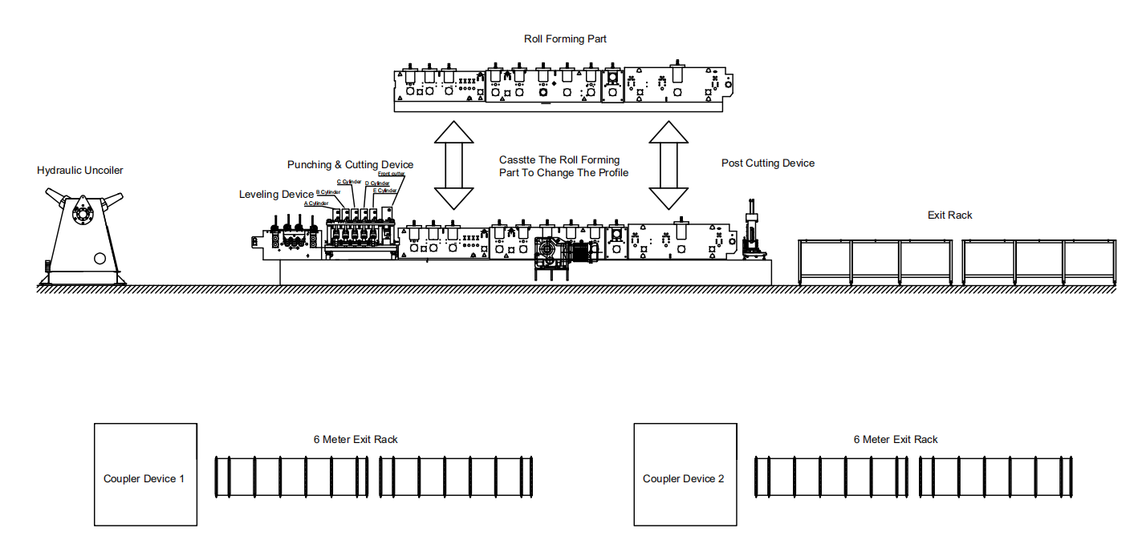

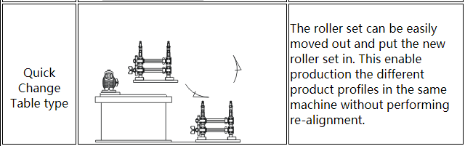

◎The Shared Device
1.Hydraulic Uncoiler 6.Body Frame H450 Steel
2.Leveling Device 7.Exit Rack
3.Hydraulic Pre-Punching Device 8.Motor
4.Hydraulic Pre-Cutter Device 9.PLC Control System
5.Post Hydraulic Cutter Device 10.Hydraulic Station
◎Then Change Device
1.Roll Forming Part
2.Post Cutting Mould
◎5T-500 Hydraulic Uncoiler:One Set
Hydraulic Control Steel Coil Inner Bore Shrinkage And Stop
Max. Feeding Width:600mm
Coil ID Range:508+/-30mm
Max Capacity:5 T
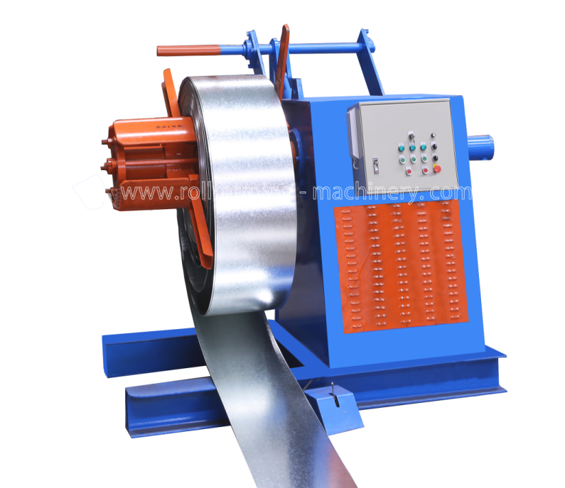
◎Leveling Device:One Set
With Feeding Material Guide
Side Wall Thickness: Q235 t18mm
Up Three Down Four Totally Seven Shafts Leveling Device
Body Frame Made From H450 Type Steel By Welding
Shafts Make From GCr15 Steel,Diameter=φ95mm,High Frequency Heat Treatment
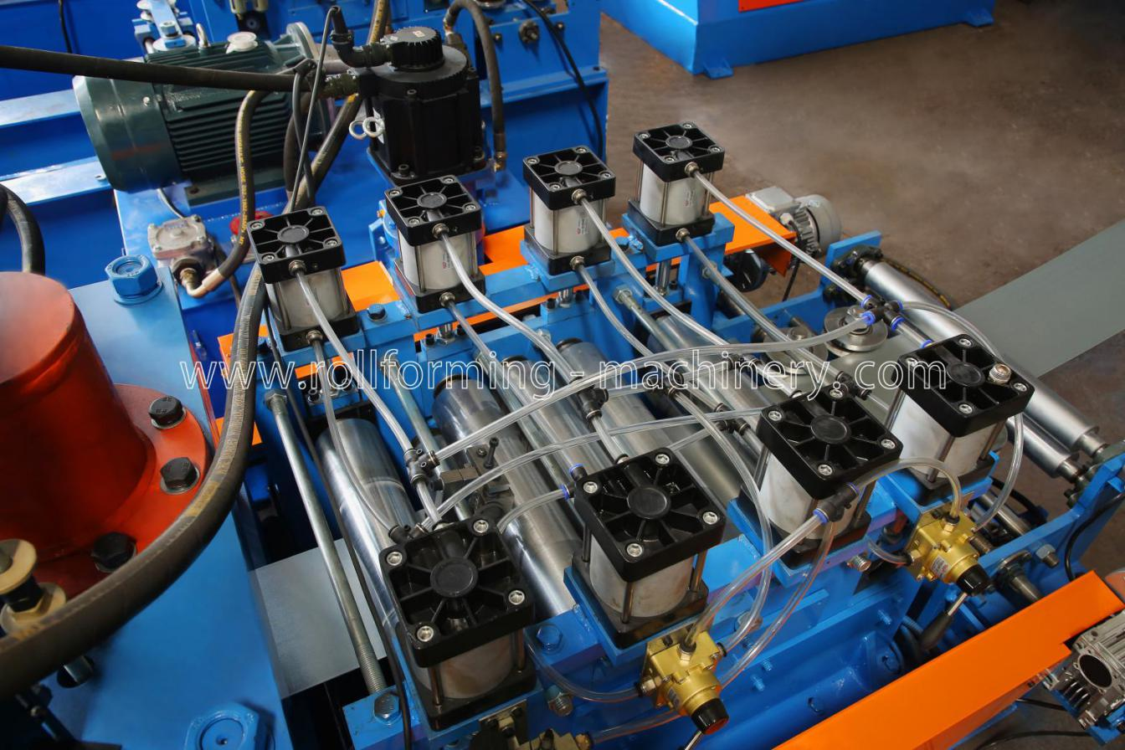
◎Hydraulic Pre Punching & Cutting Device:One Set
Pre-Punching & Cutting And Post-Cutting,Use The Same Hydraulic System
Hydraulic Motor:11KW,Hydraulic Pressure Range:0-16Mpa
Punching & Cutting Tool Material:Cr12MoV(=D2 Steel),Heat Treatment To HRC58-62
5 Hydraulic Cylinders Punching System For Punching Both On Web And Flange
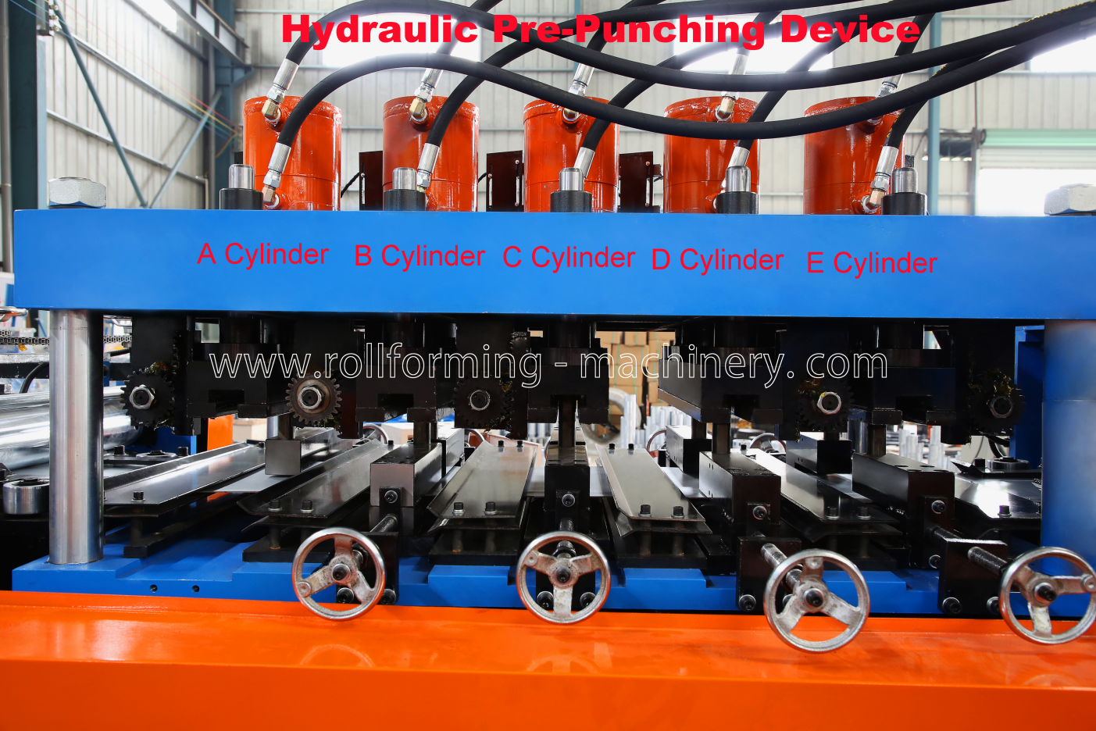
The Punching On The Web And Flange Will Be Done Through PLC Programme Automatic;
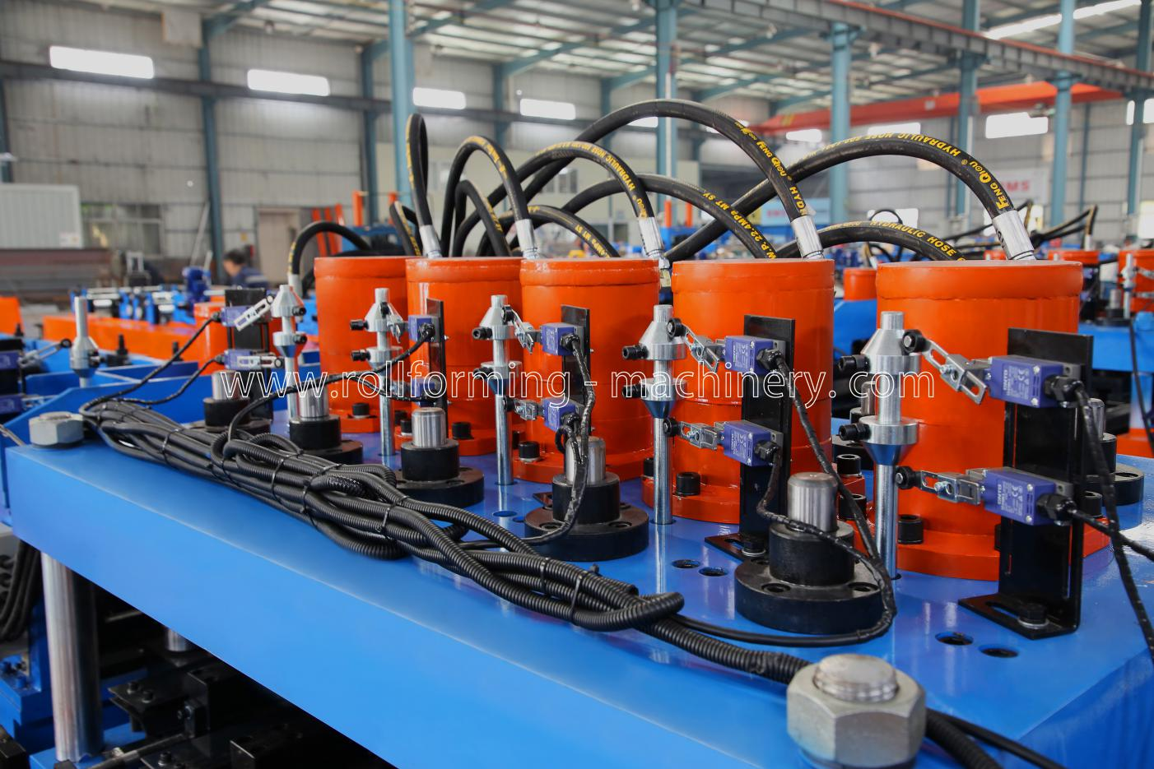
Punching Holes Show:
A Cylinder:To Punching The 7mm*17mm Oval Holes(One Punching Mould)；
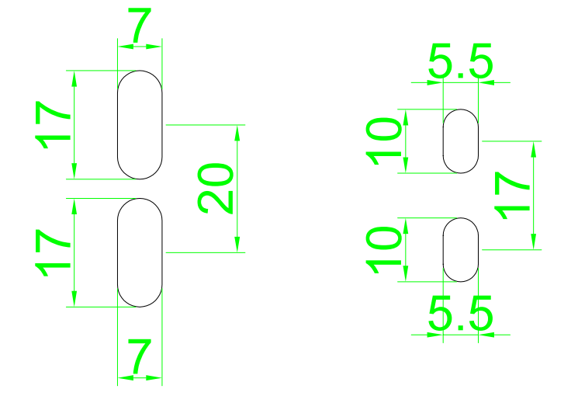
B Cylinder:Punching The 5.5*10mm(One Punching Mould)；
C Cylinder:Punching The 6mm*14mm(One Punching Mould)；
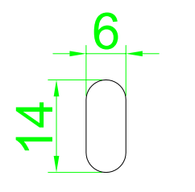
D Cylinder:Punching The Dimple Hole(One Punching Mould)；
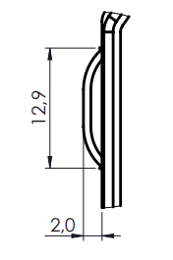

E Cylinder:Use The E Cylinder To Punching Left And Right Notch,Then Use The Post Cutting Device To Cutting The 8mm Width Material.

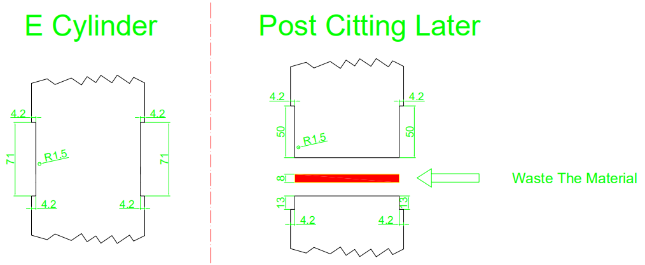

Hydraulic Pre-Cutting Device:One Set
Profile 1 & Profile 2 All Use 400mm Feeding Width,But When Change The Roll forming Part need Use Hydraulic Pre-cutting Device To Cut The Plate,So I add This Cutting For you.
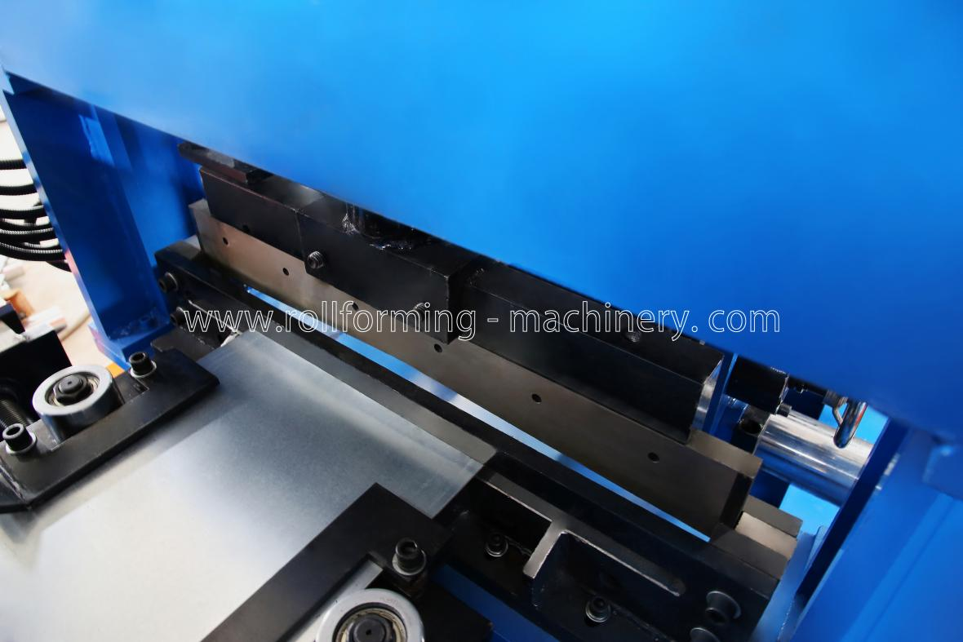
Hydraulic Station With Air Cooling Device:One Set
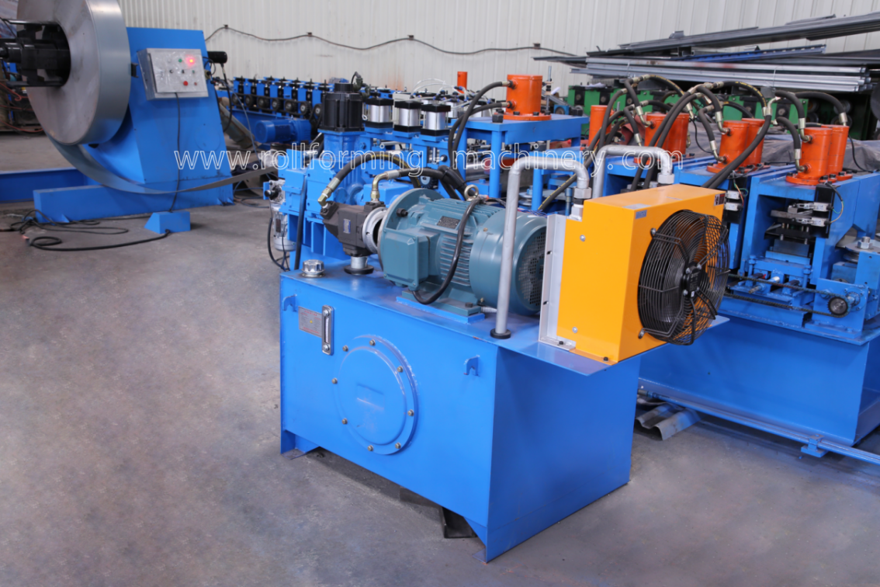
◎Roll Forming Part:One Set
Body Frame Made From H450 Type Steel By Welding;
Side Wall Thickness:Q235 t18mm;
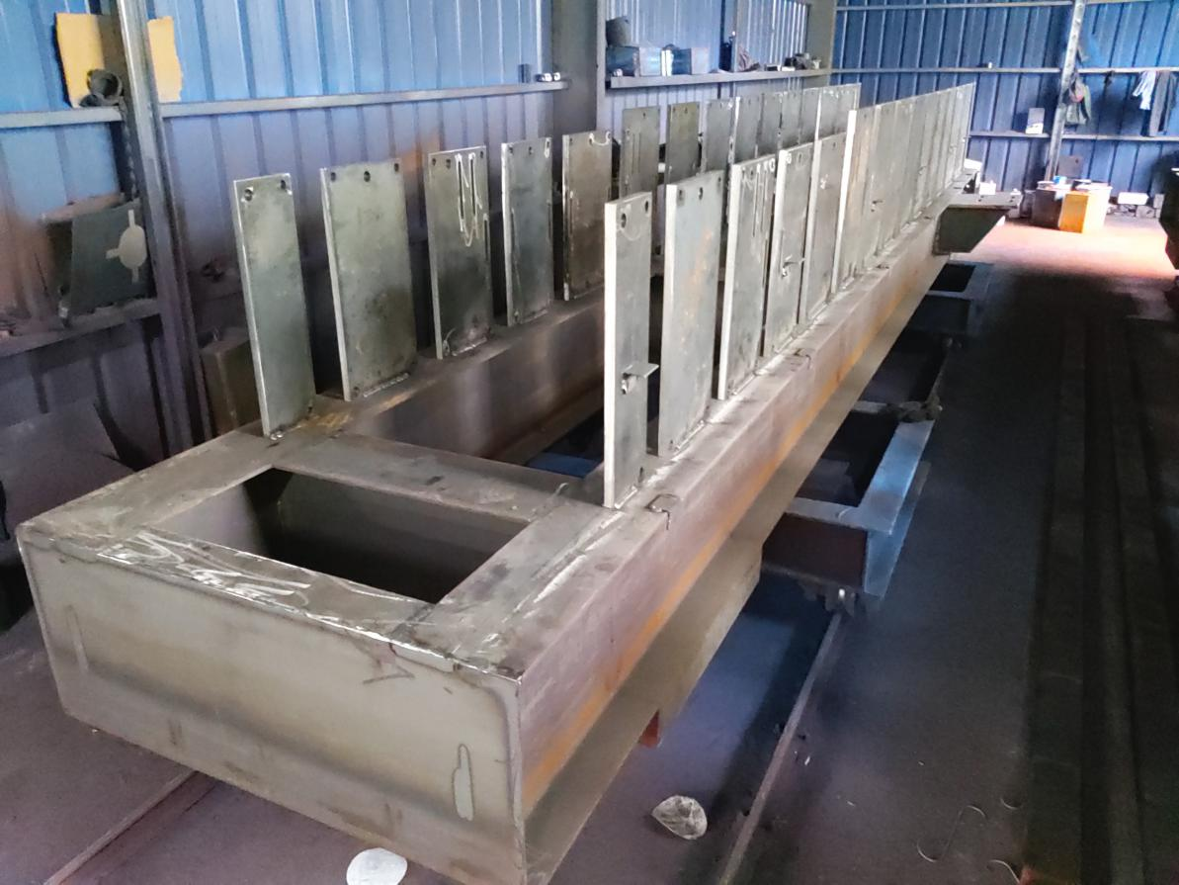

Rollers Make From 45# Steel,Precision Work,Hard Chrome Plating;
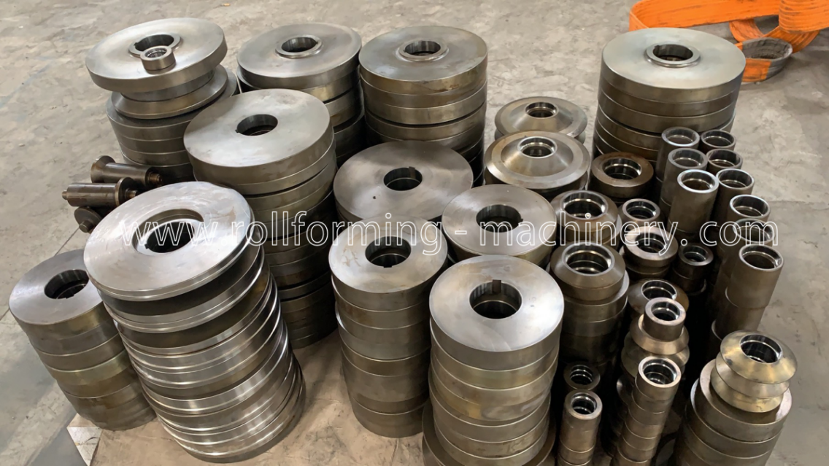
Shafts Diameter=ф75,Make From 45#,Quenching And Tempering;
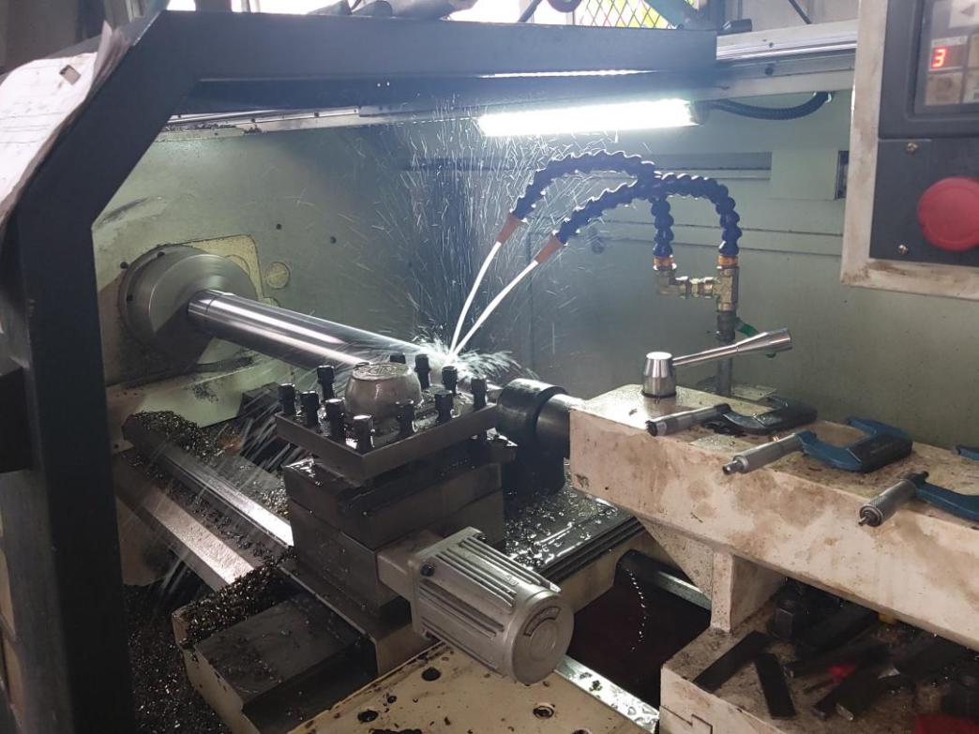

Gear/Sprocket Driving,18-Steps To Form Profile1 & 18 Steps To Form Profile 2;
Servo Motor=11KW , Frequency Speed Control;
Speed Redcucer Motor:K Series;
Sliding Block:130*140mm;All The Screw Bolts With Grade 8.8;
Real Forming Speed:22m/min;
◎Post Hydraulic Cutting Device
Post To Cut, Stop To Cutting,Three Pieces Type Of Cutting Blade Design;
Hydraulic Motor:11KW;Cutting pressure: 0-16Mpa;
Cutting Tool Material:Cr12MoV(= SKD11 With At Least One Million Times Of Cutting Life),Heat Treatment To HRC58-62 Degree;
The Cutting Power Is Provided By The Main Engine Hydraulic Station;
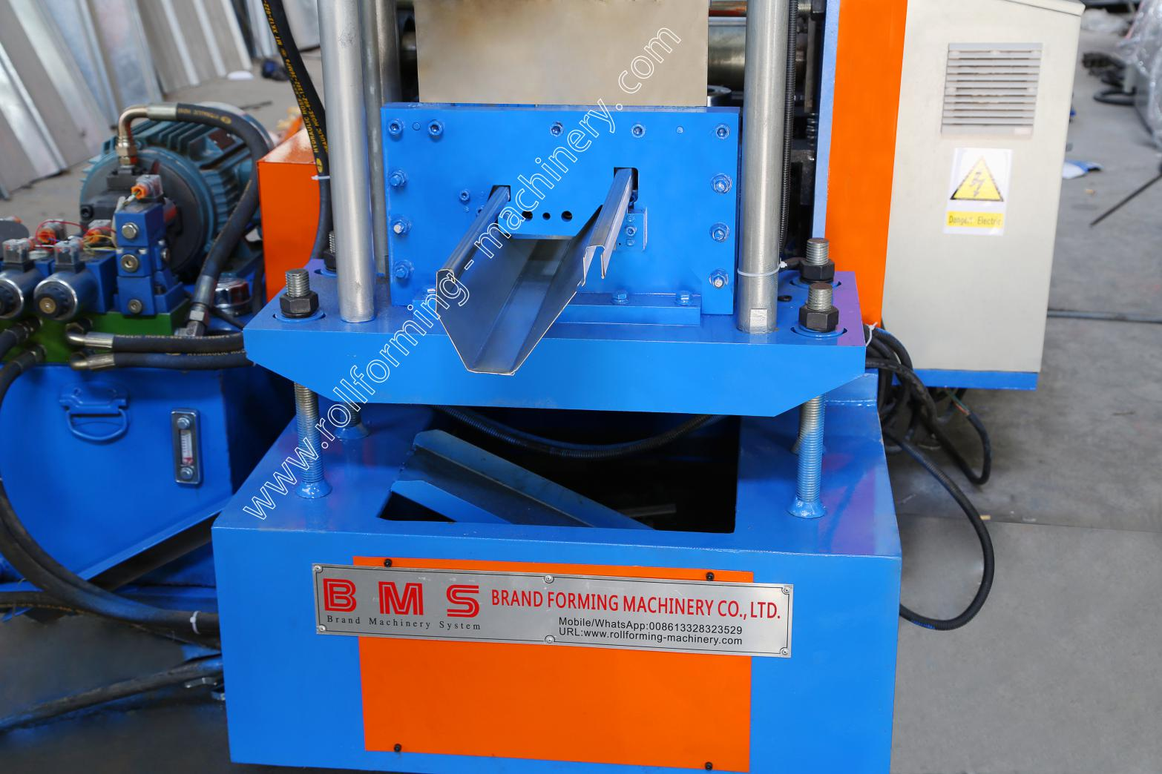
◎PLC Control System:One Set
Control The Quantity And Cutting Length Automatically Input The Production
Data(ProductionBatch,pcs,Length,etc.)On The Touch Screen,It Can Finish The
Production Automatically.Combined With: PLC, Inverter, Touch Screen, Encoder
Switch Bottom, Indicate Light, Power Supply, Intermediate Relay, AC Contactor;
PLC:Schneider(France Brand);
Inverter:Schneider(France Brand);
7-Inch Color Touch Screen:Schneider(France Brand);
Encoder:Omron (Japan Brand);
Thermal Relay:Schneider(France Brand);
Air Switch:LG-LS(Korea Brand);
Cut-to-Length Tolerance≤±1 mm;
Control Voltage 24V;
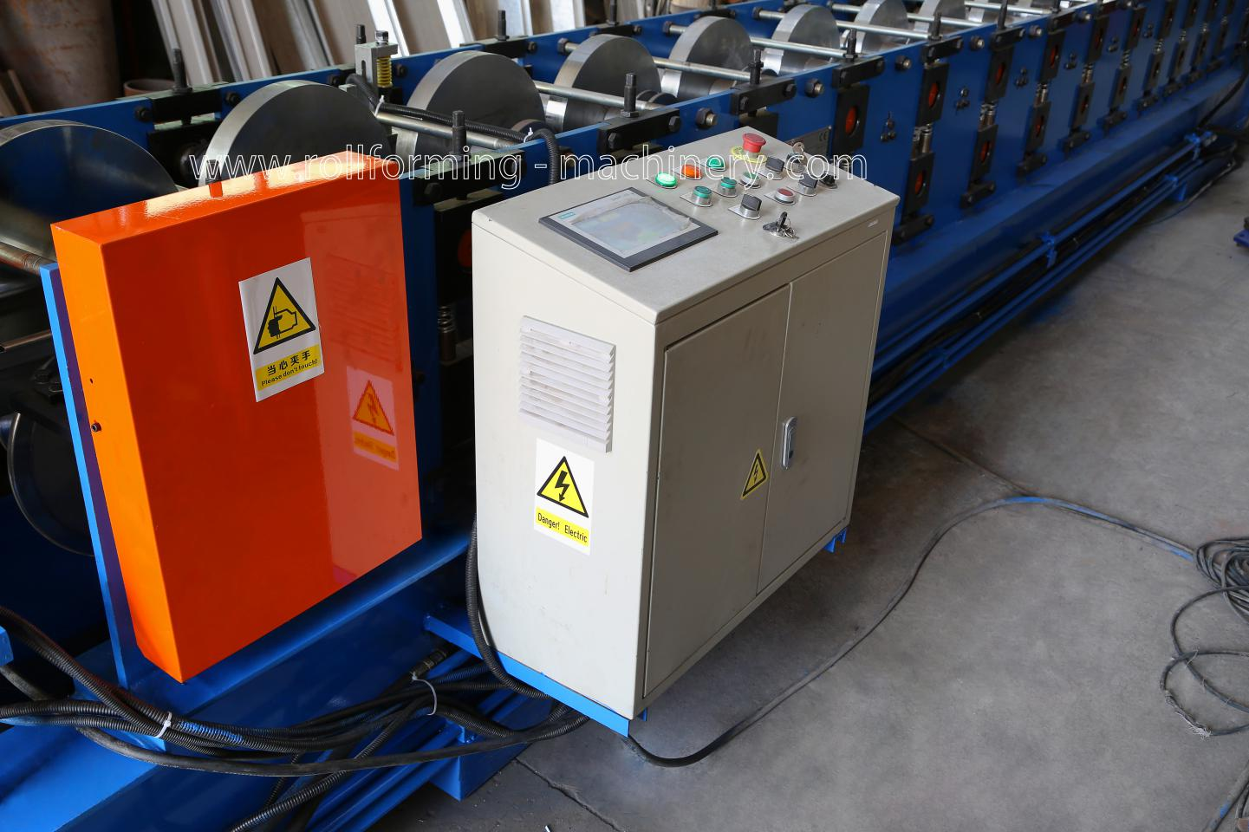
Chinese & English Language
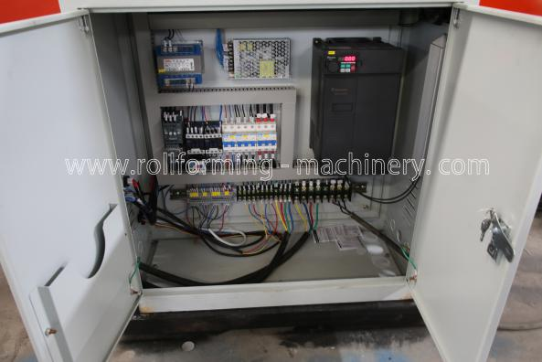
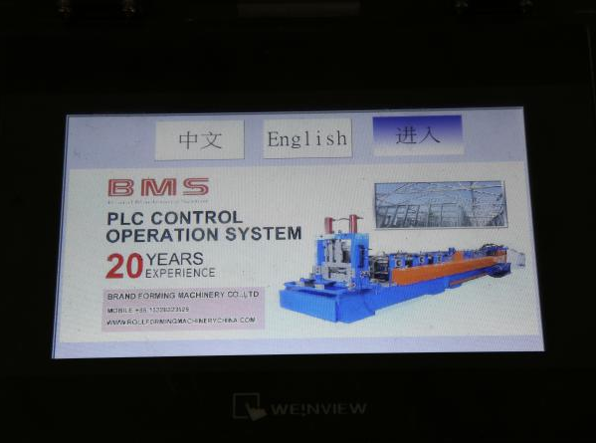
◎4 Meter Exit Rack:One Set
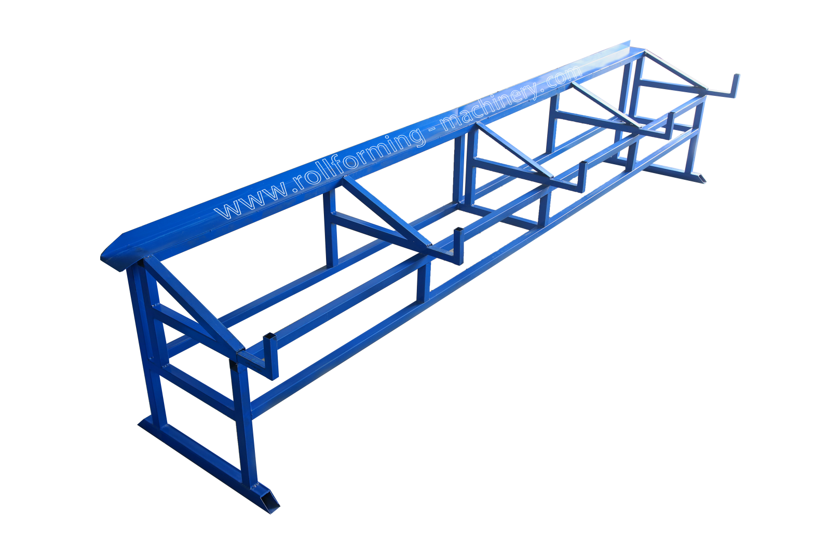
◎Coupler Hydraulic Punching Device:Two Sets
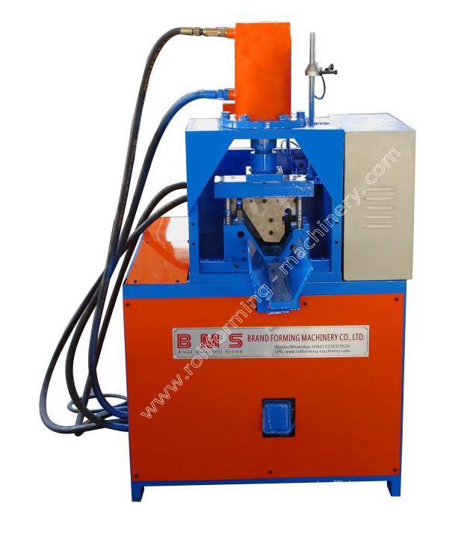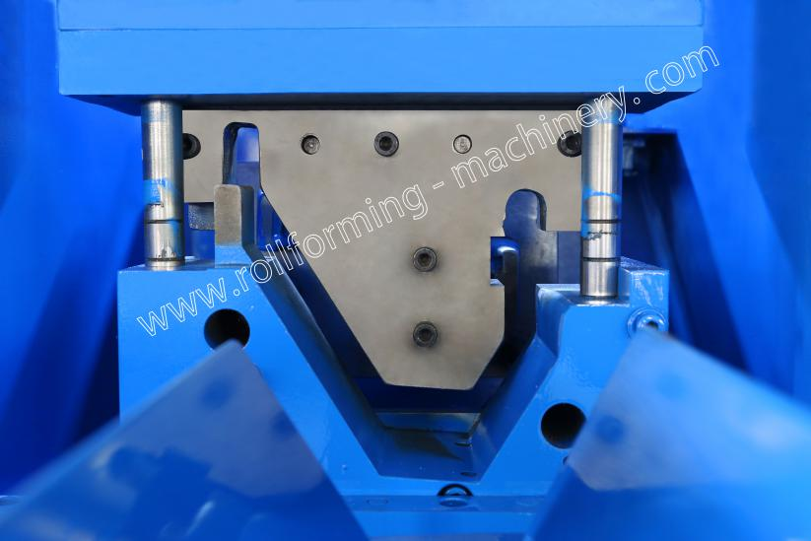
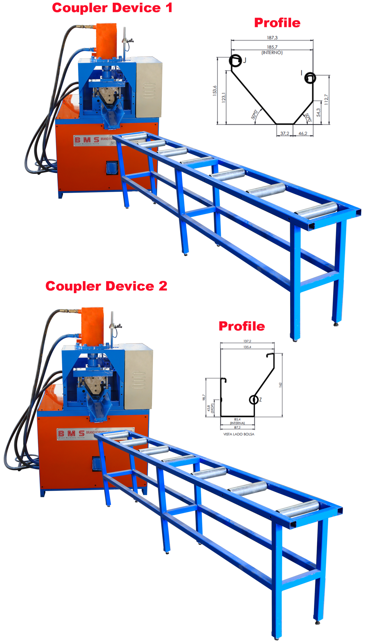
◎Tools And Spare Parts:One Set
Open Wrench 24x22, 22x19, 19x17, 17x14
A Hex Wrench (Size 1 to 10)
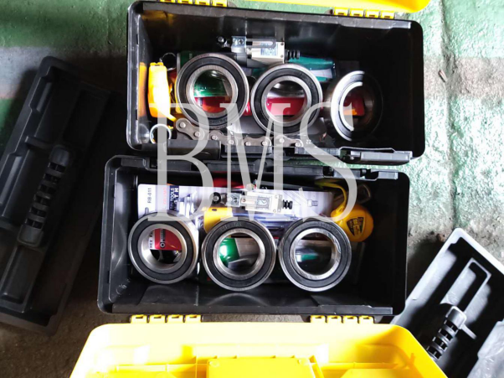
A Vise,A Cross And A Flat-Head Screwdriver, A Feeler,A Iron A Hammer, A Tape Measure
Spare Parts:
1.Drive Chain x 1
2.Drive Bearing x 2
3.Limite Switch x 1
◎Sample Show
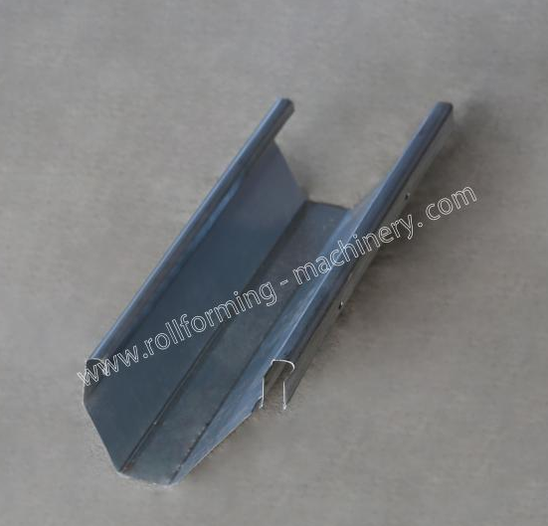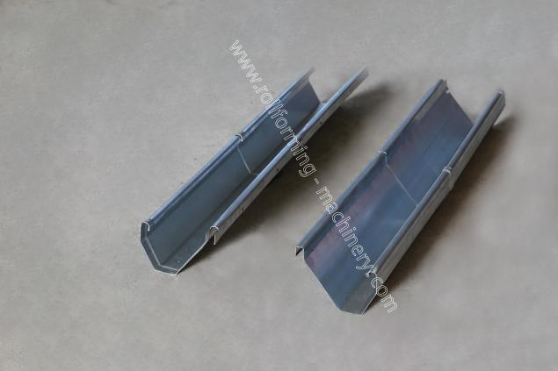
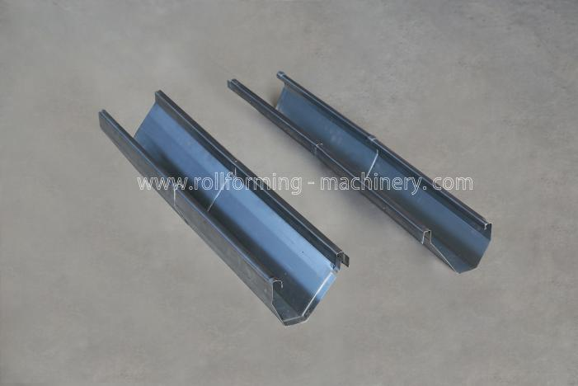
◎Price
NO. | Item Name | Quality | Delivery Time
1 | 5T-500 Hydraulic Uncoiler | 1 | 75 days
2 | Leveling Device | 1 | 75 days
3 | Hydraulic Pre-Punching Device | 1 | 75 days
4 | Hydraulic Pre-Cutting Device | 1 | 75 days
5 | Roll Forming Part | 2 | 75 days
6 | Post Hydraulic Universal Cutting Device | 1 | 75 days
7 | PLC Control System | 1 | 75 days
8 | Exit Rack | 3 | 75 days
9 | Coupler Hydraulic Punching Device | 2 | 75 days
10 | Tools And Spare Parts | 1 | 75 days

